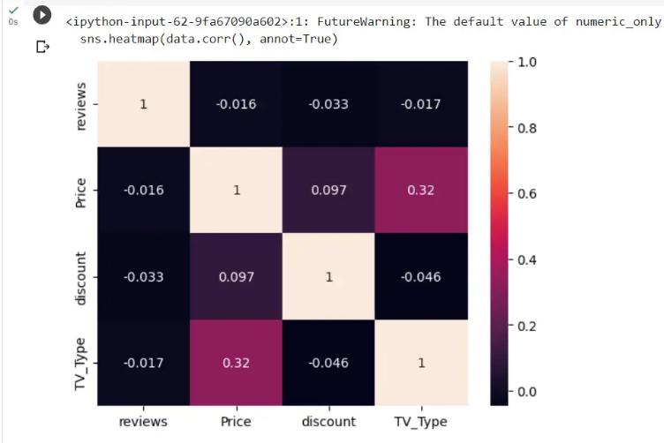

It's a heatmap. Say that, price and tv_type has better correlation compared to others

So based on this, based on the Tv type price varies. Discount and price are not linked together.

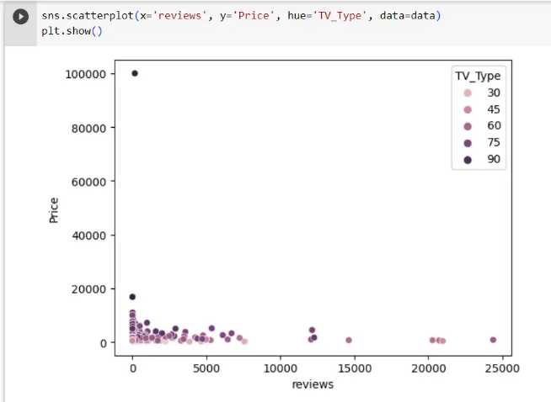

The tv type shows the various size of tv that is available. It's clear that, the price is in the lower side for most of the tv size and as the size increases the cost increases.

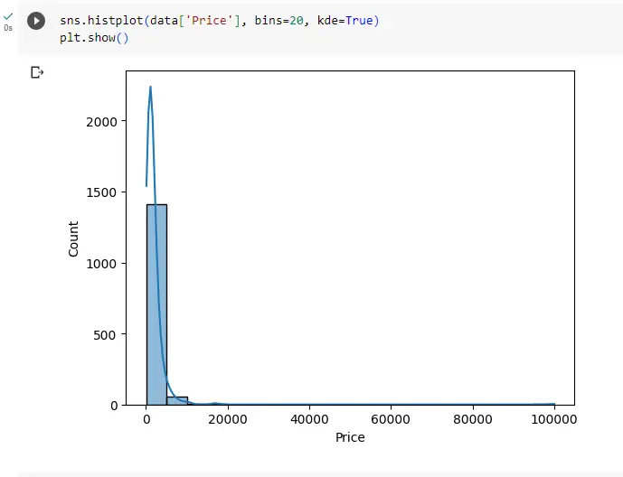

It's just a plot showing how the price works. Notable thing is, all price mostly lies less than 10000

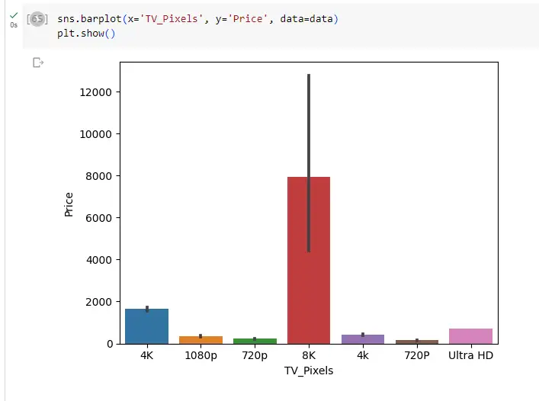

8 k resolution tv are available the most that's available in which the price lies between 4000 to 12000

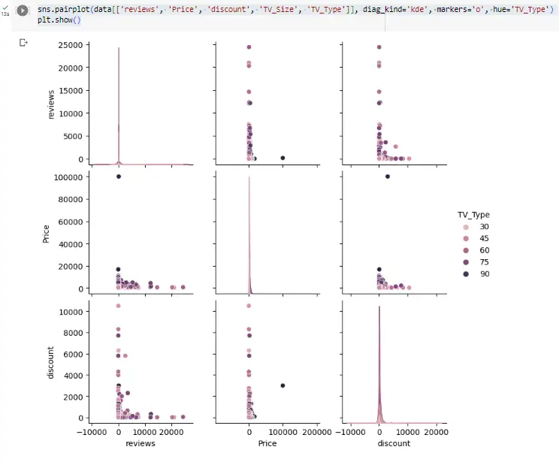

This is a scatter plot matrix, in which we compare price, discount and reviews with respect to the size of the tv. Most of the products, have discount scattered all over. Discount is not important feature and it is visible through this graph based on how it is positioned.

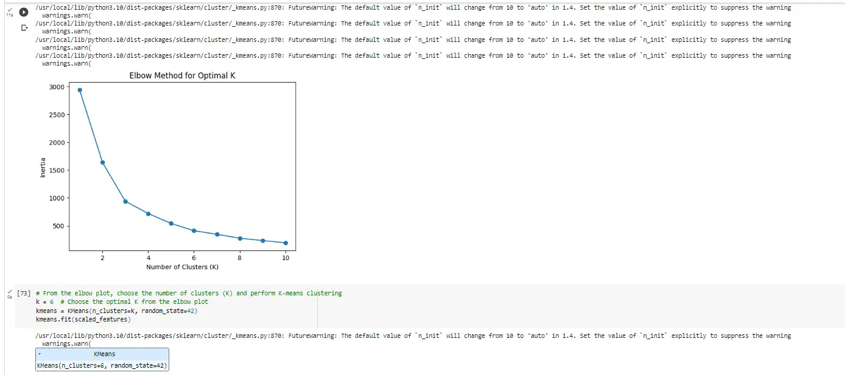

its there in comments that 6 was optimal so i chose it. the method is elbow method.

cluster basically enhances the model. we chose 6 as in this graph, 6 is the optimal number we can choose. the visual suggests the slope providing a better value to split. here error starts to stabilize or reaches a minimum.

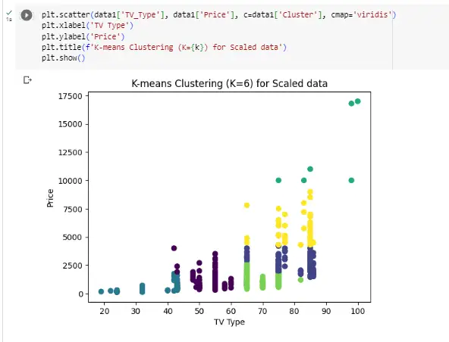

This plot is just depicting, how the tv type and price is behaving when we group them with clusters and it isn't overlapping so its optimal.

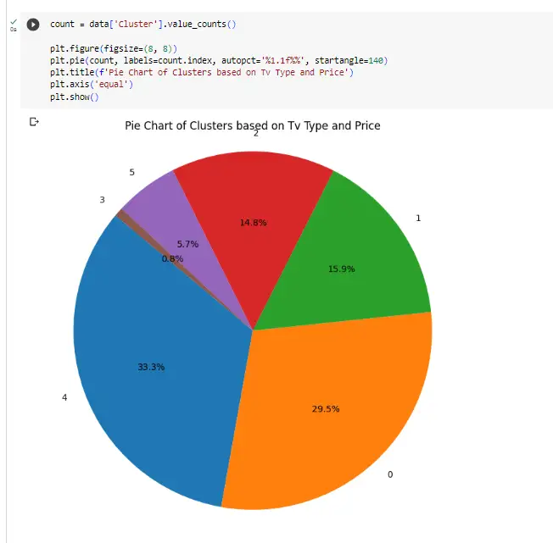

the title explains it. It shows the constituency of each cluster in this dataset.

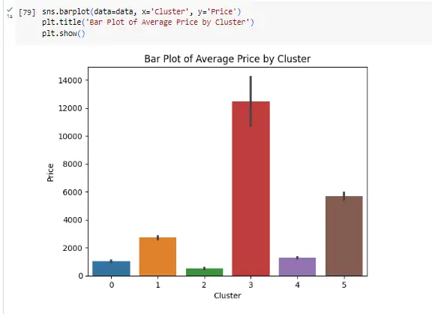

cluster 3 has the higher priced data compared to others. Group together.

Adnan bhai what is the use of decision_tree = DecisionTreeRegressor(random_state=42)

decision_tree.fit(X_train, y_train)?

Its a model to predict the price of tv. They can handle non-linear relationships, missing values, and are suitable for feature selection. They are a building block for powerful ensemble methods like Random Forests, improving prediction accuracy and generalization. so we use them.

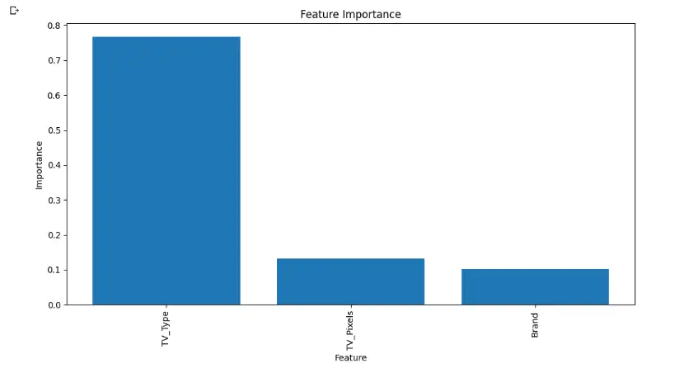

this implies the the most important feature here is tv_type followed by pixel and brand. TV_type is a critical feature to decide price.

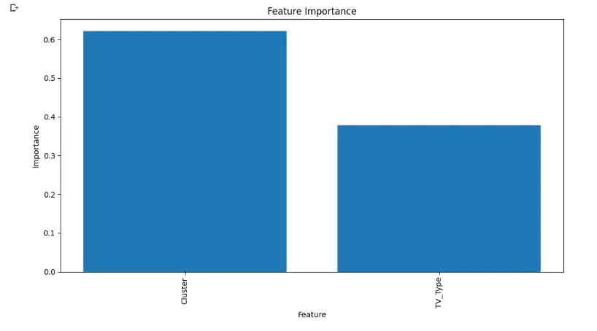

so when u cluster the data, cluster holds more important value in determining the accuracy of the data compared to tv_type.

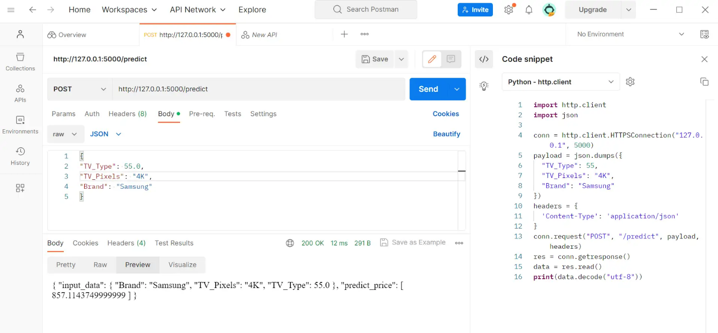

It has predicted the price.